Examples of Tameside Guidance and Resources

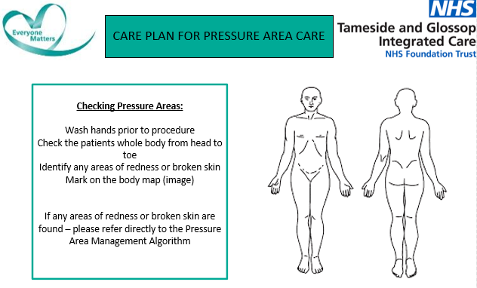
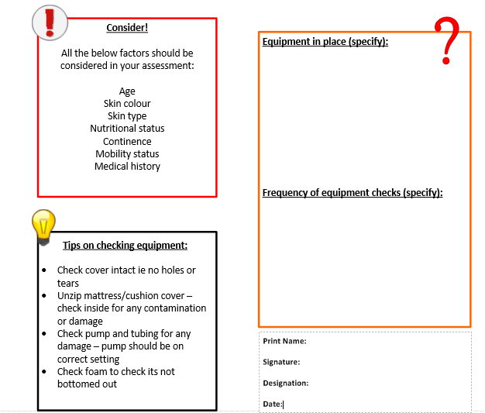
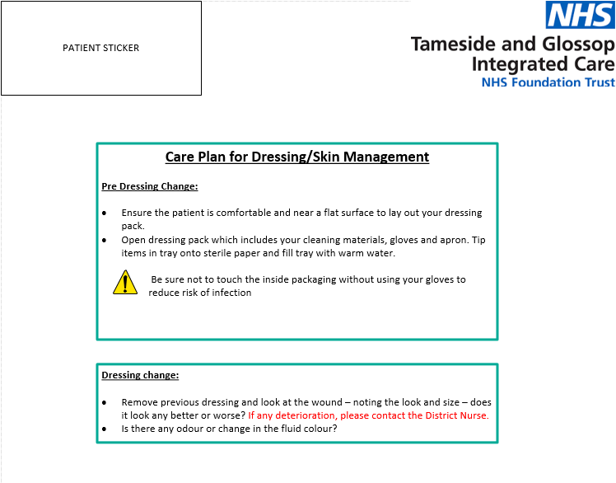
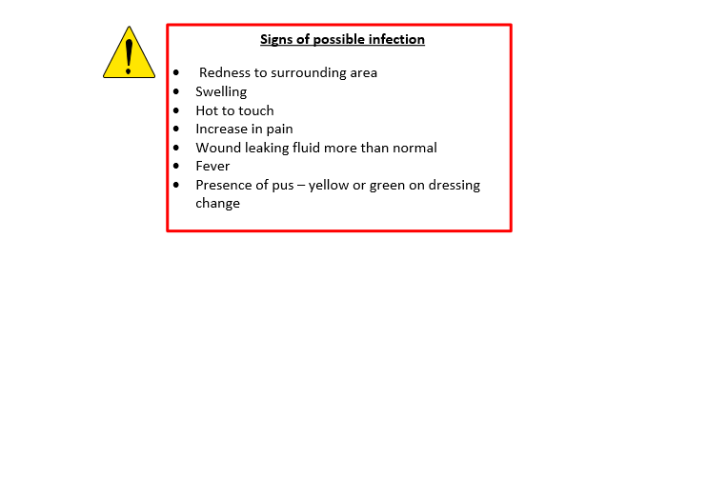
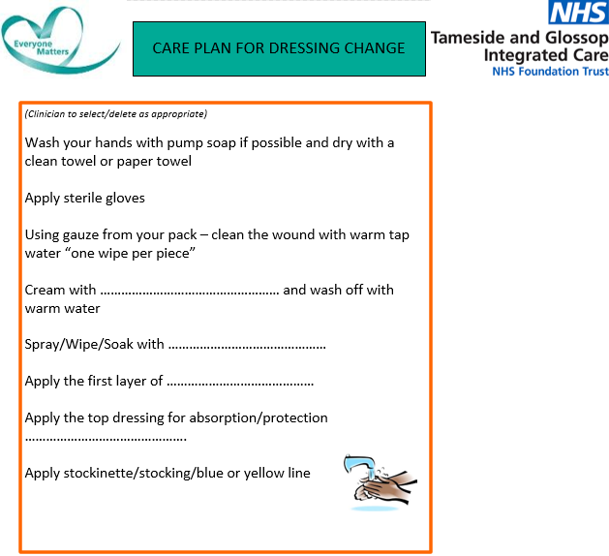
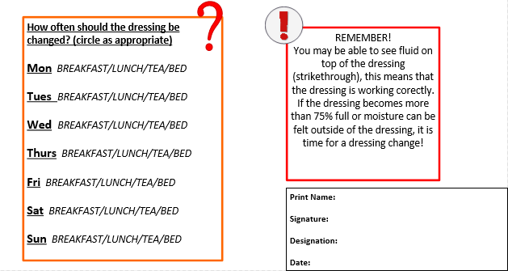
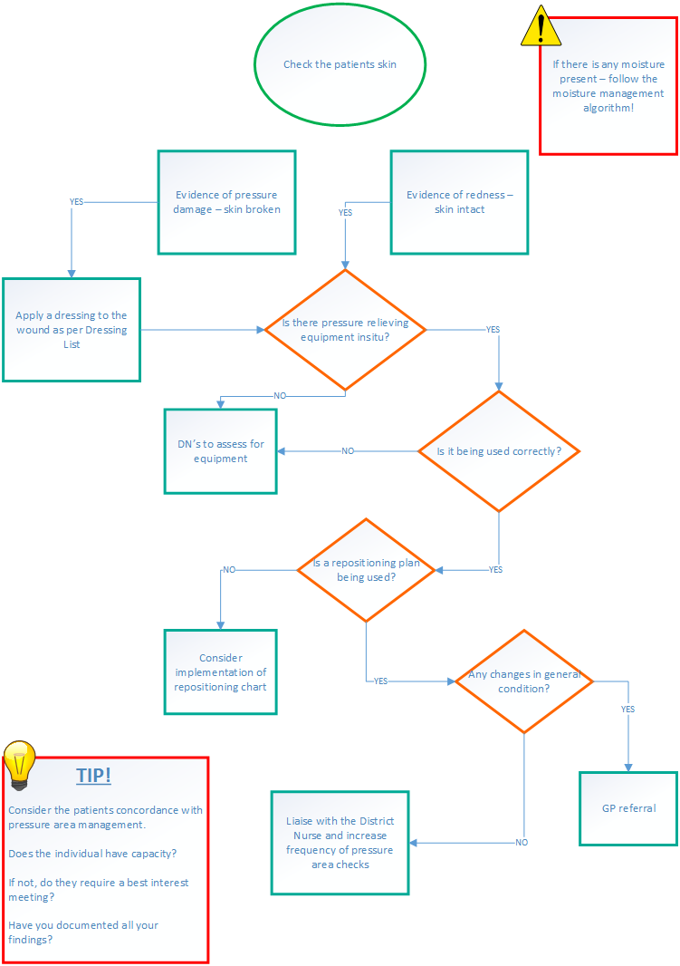
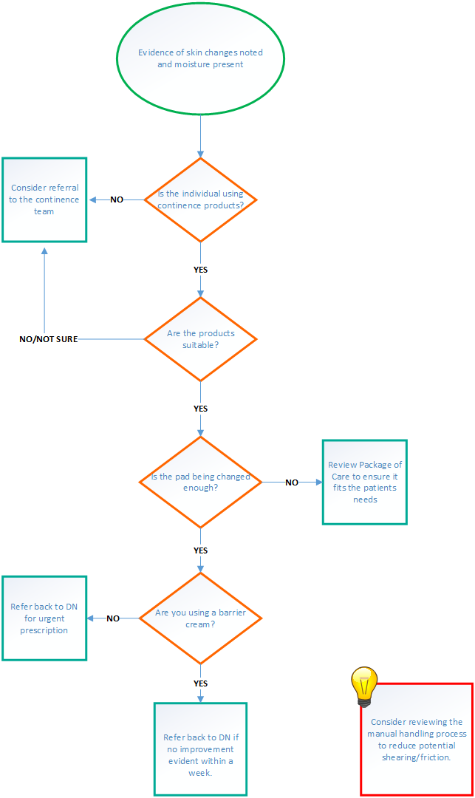

Multi Professional Communication Sheet
The purpose of this form is to record professional discussions regarding patient/ service users known to one or more services i.e. Person known to DN service who may also have involvement from a Care Provider and known to a Social Worker. This record will be completed and a copy stored in the Individual records of each provider at their base. If Urgent the usual referral process via Single point of Contact/ Duty Social Team should be followed.
Name: DOB: NHS Number: IAS Number:
Care Provider | Main Concerns | Action (& by who)

