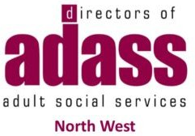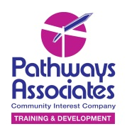
Tell us your story!
 | Some tips for telling your story:
 | 1. Try to give it a start, middle and end!
 | 2. Tell us:  - How you were affected by the lockdown?  - What happened?  - Who was involved?  - Who helped you or who did you help?  - What did you do?  - What worked or didn’t work?  - What would you like to be done differently?  - What would you like to carry on?  - How has it ended?  - How has it made you feel?  - What can learn from your experience?
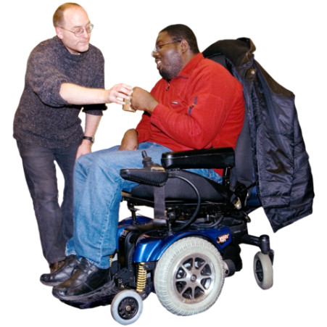 | 3. Please say how your community supported people with social care needs.
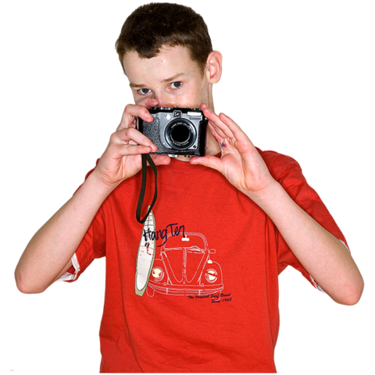 | 4. If you send photos, make sure the people in them have agreed for them to be used.
 | 5. If you don’t want to name people or organisations, just change the name or leave them out.
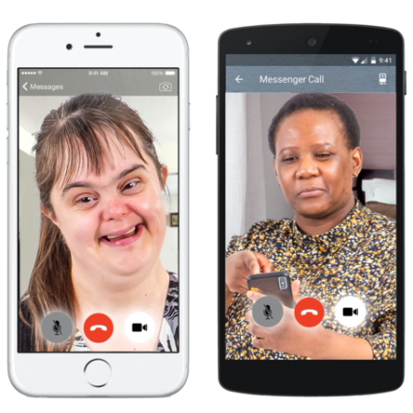 | 6. You can record a film on your phone and send it to us instead!


Write your story here.

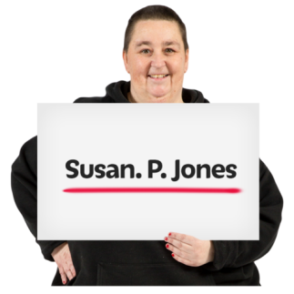 | Name: ______________________
 | Email: _______________________
 | Telephone: ___________________
These details will be held by North West ADASS whilst the project happens and then destroyed.

They will not be shared with any other organisation or person.
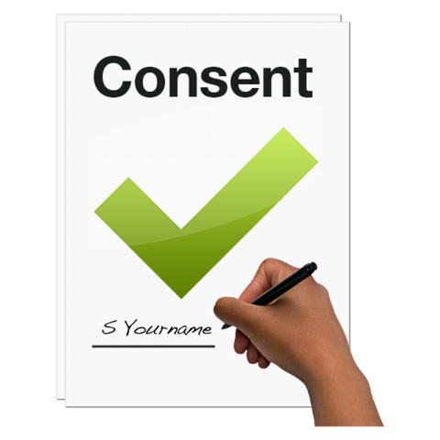 | Please sign or print your name to confirm:  - People in photos have given their permission to use their image.  - You are happy for us to share your story with our Elected Member Commission.  - You are happy for us to publish your story.  - We can contact you for more information.
 | Signed:  ____________________________
 | Please email nwadass@nwemployers.org.uk with any questions about this project.

