North West Associate of Directors of Adult Services (NWADASS)
Position Statement

Response to:

Adult Social Care (ASC) White Paper – People at the Heart of Care

- Introduction

With the publication of the government ‘People at the Heart of Care: adult social care reform white paper, on 1st December 2021 this statement sets out the position from a NWADASS point of view and how we will respond to the wider vision. It should be noted that the paper sits alongside “Build Back Better: our plan for health and social care” which set out a range of measures, including reforming the way adult social care is paid for and funded. This paper does not intend to set out a summary of the paper but to briefly set out the NWADASS position statement and then to set out how we will continue to transform services and work towards our ambition for local authorities in the NW region.

This statement is written in a spirit that recognises that Local Authorities (LAs) in the NW with responsibility for social care have proactively worked with and alongside partners in health, the Voluntary, Community, Faith and Social Enterprise (VCFSE) sectors, housing and social care providers to develop new ways of working and manage demand in a rapidly changing systems across the region.

We also wish to confirm that NWADASS also has a clear commitment to sector led improvement and has and will continue to use this to drive better outcomes across the region.

- The ASC White Paper People at the Heart of Care: adult social care reform white paper - GOV.UK (www.gov.uk)

The ASC White Paper sets out a 10-year vision for care and support in England and is based around three key objectives:

- People have choice, control and support to live independent lives
- People can access outstanding quality and tailored care and support
- People find adult social care fair and accessible

It recognises that social care is at the heart of our communities, the sector focuses on prevention and early intervention which demonstrates the size and nature of social care. It is about all adults and identifies the wide range of activities and settings underpinning social care recognising that the care workforce is our biggest asset.

It also recognises the contribution of unpaid carers as well as the individual and the crucial importance of a person-centred approaches, which sets out the importance of people living well at home. It is also clear that local authorities, providers, and the wider sector have been working to transform services for many years and there are numerous examples of good practice across the country. Whilst the vision and language in the paper is not new it does demonstrate that there is a wide consensus over what good ASC looks like and that should be welcomed.

There is a welcome focus on housing, with £300 million to help develop new supported housing options, a new ‘handy-person’ service and more money for Disabled Facilities Grants. There’s also £150 million to drive greater adoption of technology and small pots of money to improve services for carers (£25 million), improve local innovation (£30 million), and improve planning (£70 million).

- NWADASS Key Messages

NWADASS Executive December 2022 discussed the paper and agreed:

- We welcome the positive framing of ASC within the paper and the focus on individuals, living at home, within communities, We also welcome building on the ambition of the Care Act 2014, the recognition of our skilled workforce and focus innovation and new ways of working which are being developed across the country and is a clear ambition for the NW. There was a consensus that the White Paper has lots of good elements to it, which we have been working on and collectively can get behind. We have many examples of community and asset-based approaches alongside well developed integration at place.

- In the NW, we see the primacy of people living in a place, leading their best lives with families, friends, and communities. This coincides with NWADASS Care 2030 Vision: “Making Every Day, The Best It Can Be”. The Care 2030 Strategy sets out our ambition to deliver reform in three key areas of work: Future Models; Future Markets; and Future Workforce. All this work is underpinned by a fourth priority of Sector-Led Improvement Programme that offers all NW Local Authorities an offer of support to deliver improvements.

- In September, the Government announced £5.4bn over three years for adult social care reform to be funded through the new Health and Social Care Levy, including £1.7bn to help improve the wider care system. The White Paper describes the priorities for investment of this resource. We welcome the availability of additional funding and the focus on housing and digital solutions as well as investment to support innovation and would very much welcome, as a region, to be involved in the development of the implementation programme. However, we are concerned that the level of funding available fails to match the ambitions for reform set out in the paper. Our concerns are:
- There is funding for targeted Local Authorities on innovation, it is only likely that these authorities will benefit, and this will not be scaled up given the continuing funding challenges.
- There was concern from the Board on the assurance reforms and ‘setting areas up to fail’.
- There was concern over some parts of the system may be ‘over simplifying’ the challenges of the ASC sector.
- Announced funding fails to provide the level of investment required in the reform and sustainability of the care workforce and care markets. There was a significant discussion on the ‘Fair Cost of Care’ (FCC) work and implications for the NW, as a region with the cost implication likely to be significantly in excess of available funding.

- Overall, the paper does not recognise the urgent challenges we are currently facing e.g., workforce pressures, both in commissioned services and within Local Authorities’ own services, the fragile marketplace, rising demand both in terms of numbers and complexity. All of these are underpinned by a lack of sustainable funding.

The paper has been broadly welcomed by the sector including the LGA and ADASS: “The White Paper - People at the Heart of Care - should be seen as a first but highly significant step on a journey of transformation” Stephen Chandler, ADASS president. However, this is heavily caveated by concerns about core sustainable funding and managing current pressures and challenges of the sector. The Kings Fund response to the White Paper suggests “It’s not that the White Paper takes us in the wrong direction, just that it doesn’t move us very far forward in the right one. And, as often, lack of money lies at the heart of the problem.”

We believe that over past two decades our sector has already set the direction of travel, but the white paper has not addressed why this vision has not always been achieved.

Social care is set to receive just £5.4 billion of the £30.3bn expected to be raised through the Health and Social Care Levy over the next three years, with the majority of funding prioritised for the NHS. We remain concerned that this funding envelope does not fully account for the true cost to local authorities of the charging reforms and fair cost of care; or provide the level of investment resource required to deliver on the vision for adult social care set out in the White Paper. Furthermore, funding announced in September and in the recent funding settlement, fails to adequately address existing and future funding pressures for councils driven by demographic change and the rising cost of providing care.

Sustainable funding is required to stabilise core services, tackle unmet need, stabilise the provider market and address immediate workforce challenges – to deliver a foundation for future reform. Without sustainable funding, the White Paper is setting out its ambition but leaving the sector at a disadvantage which may mean the ambitions may not be realised.

- Wider National Policy Context

The ASC White Paper – People at the Heart of Care also needs to be seen in the wider national policy context. The implementation of these reforms and policies adds challenge and extra pressure to an already beleaguered sector.

Key pieces of reform over the last 18 months include:

- Health and Care Bill
- Build Back Better: our plan for health and social care
- ASC White Paper – People at the Heart of Care
- Norfolk Judgement
- Disability Strategy
- Mental Health Act Review
- Mental Capacity Act 2019 – Liberty Protection Safeguarding (LPS)
- Autism Strategy
- LeDeR Review
- Data Safes Lives
- Domestic Abuse Act 2021

- How will we deliver the reform in NWADASS

As mentioned above the NW has set a clear direction of travel with our vision for the future. A clear programme approach has been agreed with the NWADASS Executive Board, which will enable the delivery of the NW priorities. This approach wraps support around our four-priority work-streams, as well as our extensive NW Networks. The governance structure (diagram 1) is set out below:

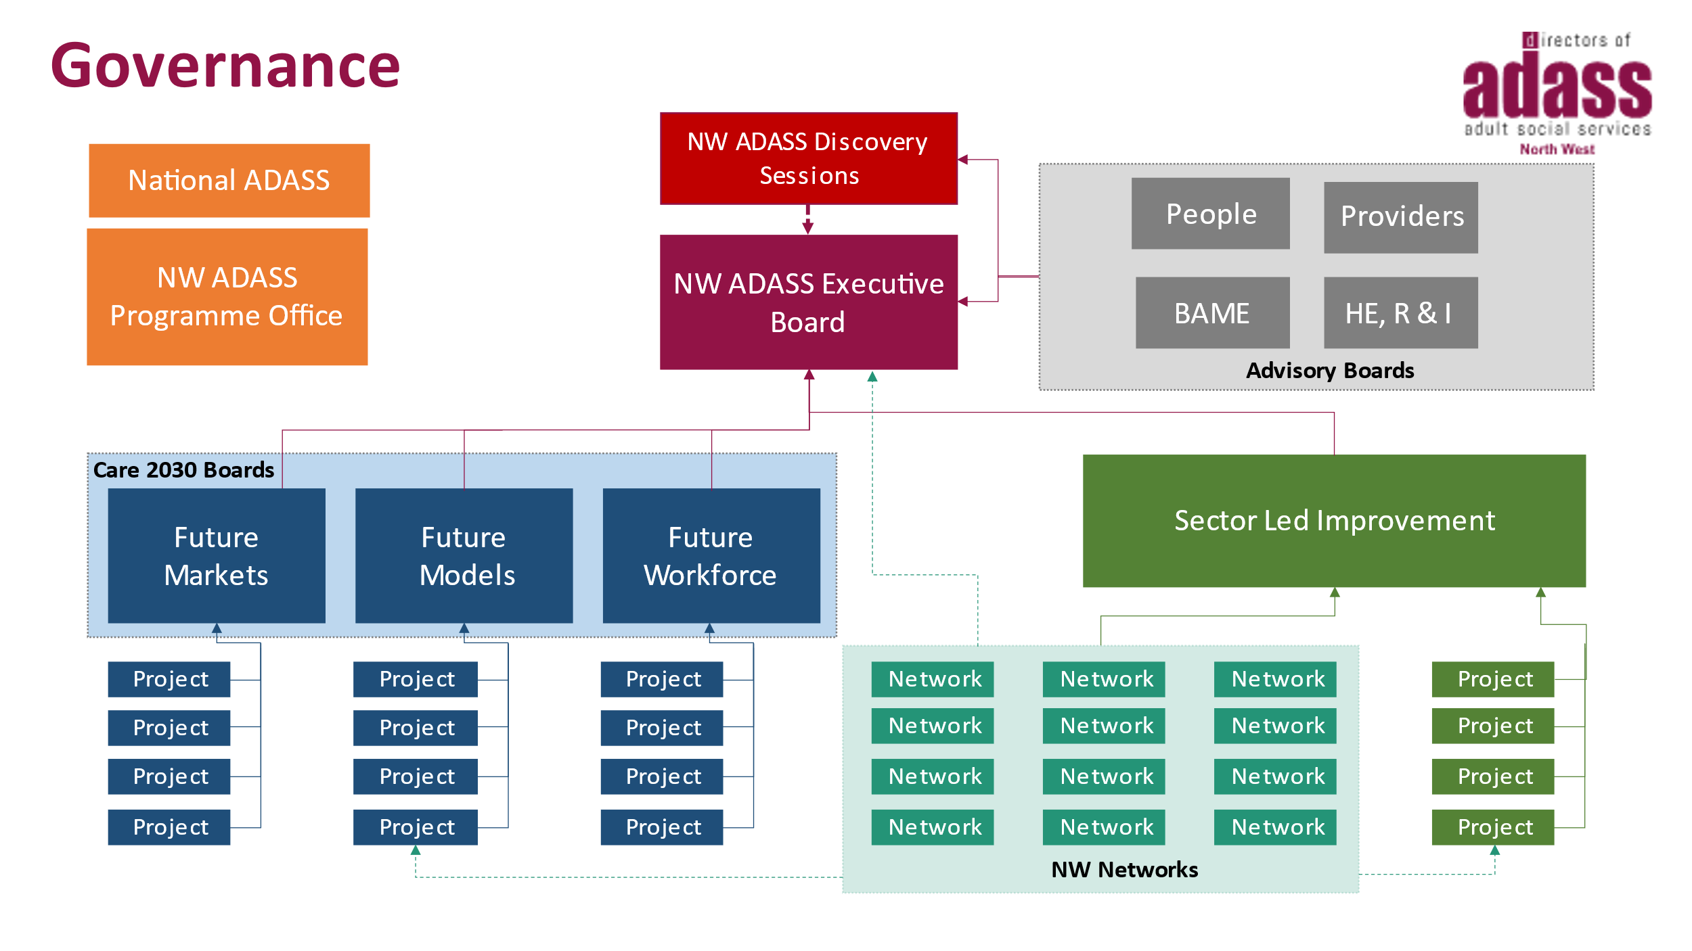
Diagram 1 – NWADASS Governance and Programme Approach

The programme office for NWADASS has mobilised all four-priority work-streams with a clear purpose for the programme oversight Boards. These are:

Future Models
- Developing new ways of supporting people so they can live the life they want in their community.
- Identifying and testing new models of care i.e., Extra Care Models., Day Opportunities.
- Priority work includes early intervention and prevention, VCFSE offer, integrated health and social care services, housing models and digital and tech.

Future Markets
- Plan the Future Markets Programme with a key priority to improve data and insight via the Market Quality Insight System (MQIS).
- Monitor the delivery of the Future Markets Programme and its prioritised projects, which include: MQIS; Care Quality Webinars, What Good Looks Like on understanding provider failure.
- Support the Strategic and Operational Commissioning Groups and Networks.
- Undertaking appropriate evaluation and review of the impact of the Future Markets Programme.

Future Workforce
- Develop effective data and insights into the NW workforce.
- The Board has prioritised several of key projects which that have been mobilised: NW Workforce Brand; Career Academy Toolkit; Capacity Modelling; mapping joint career pathways across health and care; mapping recruitment and retention initiatives and planning frameworks; and developing a coaching and mentoring offer.
- Tackle the immediate workforce pressures by mobilising a Task and Finish Group to deliver critical issues affecting the sector.
- Develop a clear programme of work to support Equality, Diversity and Inclusion across the sector.

Sector-Led Improvement (SLI) Programme
- Taking collective responsibility for the performance of the sector, this includes analysing data and provide insights for the sector.
- Defining what good looks like across adult social care provision in the region.
- Providing SLI support offer, peer challenge and a ‘what good looks like’ programme to drive improvement across the region
- Providing assurance to the NWADASS Executive and to central government for the performance of the collective regional sector.

- NWADASS Networks

The NWADASS Network Support are a core offer of the programme office. The Networks are supported by the 23 NW Local Authorities around several professional and thematic areas, these are:

- Carers
- Continuing Health Care (CHC)
- Tech Enabled Care
- Deprivation of Liberty (DoLs) and Liberty Protection Safeguarding (LPS)
- Finance and Use of Resources (UoRs)
- Forensic Social Work
- Learning Disabilities
- Operational Commissioners
- Mental Health
- Performance
- Prisons
- Principle Social Work (PSW)
- Safeguarding
- Solicitors
- Occupational Therapists (OT)

- Enablers to Reform

Technology Enabled Care (TEC) and a Digital Approach – at least £150 million of additional national funding will be available to drive greater adoption of TEC and digitalisation across the sector. This presents an opportunity for the region to collaborate, particularly with colleagues I health through the Integrated Care System (ICS) developments. Developing our regional approach will include a high-level vision for the ASC sector.

The vision will be based on outcomes-based personalised proactive care which maximises the use of data and technology to:
- better understand and meet need
- support the transformation of care
- connect health and care services
- empower people to take greater control
- increase independence and enable self-care
- prevent deterioration
- support and manage care markets
- meet customer expectations

This programme of work will align to the strategic direction of our 23 Local Authorities and showcase good practice and shared learning. The approach will identify opportunities for mainstreaming activity across ICSs and a wider footprint of the NW.

Communication and Engagement – NWADASS has recently reviewed it’s work in this area with a view to refreshing our approach. We have agreed some overarching aims and objectives to:

- Represent a clear and consolidated voice (re-shape the narrative for the sector).

- Maintain effective engagement of the relevant stakeholders involved in our programme and projects of activity.

- Ensure relevant national and regional sector news, updates and information are available to our regional sector stakeholders.

- Support and enable communication between relevant regional stakeholders, such as Local Authorities, health bodies, people with lived experience and adult care providers.

In January 2022 we will embark on a 90-day plan to completely refresh our current website and make it more relevant to our stakeholders and a wider audience. Work will be developed to start to re-shape a new narrative for the NW ASC sector that aligns to our vision of ‘Make Every Day, The Best it Can Be’ this will be set out in our Annual Report and Business Plan for 2022-23.

- Risks to delivery

NWADASS has developed a robust risk management approach to our sector. The principles of our regional risk approach are:

- The focus of the risk approach is on sector risks that will impact multiple areas across the region.
- The formal risk approach does not name individual local authorities unless in exceptional circumstances and with advance agreement with the DASS.
- We evidence risks or issues were identified using existing data. New data is only requested with SLI Board or Executive agreement.
- Processes are transparent, with copies of the risk tools made available to all localities on a regular basis.
- Councils are responsible for managing and mitigating adult social care risks in their locality. NW ADASS is a mechanism for collaboration to identify and respond to shared risks, to support councils in their own adult social care risk management and mitigation.

The critical overall risk is the financial sustainability of the sector as highlighted in section 3 of this position statement. Significant work is being done and will continue be done through our Finance Network leads and their ‘Use of Resource’ work with the LGA (John Jackson). We also plan to stand-up a Care Act phase 2 work via a Charging Reform Group to work on the full implications of the ASC White Paper and the Build Back Better: our plan for health and social care.

- Conclusion

In conclusion, NWADASS welcomes the ambition and positive framing of Adult Social Care set out in the White Paper. It mirrors the ambition and vision within the NW with its focus on prevention, early intervention, person centred and asset-based approaches which sees citizens leading a good life. We also appreciate the investment into housing, digital and innovation which supports that ambition.

However, we can only agree with the Kings Fund statement “It’s not that the White Paper takes us in the wrong direction, just that it doesn’t move us very far forward in the right one. And, as often, lack of money lies at the heart of the problem.” We have not seen anything in the White Paper or the settlement headlines that suggests there will be sufficient funding to address existing funding pressures in adult social care alongside the level of investment required in care markets and the workforce. The paper does not address our current position – we are seeing significant increase in demand and fewer people attracted into social care roles that are complex and personally very demanding. We need urgent support to bridge the gap we currently have.

Despite the funding and workforce challenges outlined above the 23 Directors of Adult Social Care in the NW continue to be committed to transforming services for people within their places to live a good life supported by NWADASS through the 2030 vision and SLI Programme.

