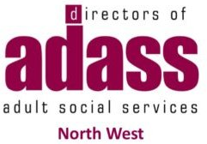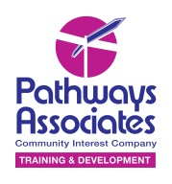
The impact of Covid-19 on adults with social care needs
 | North West ADASS works to improve adult social care.
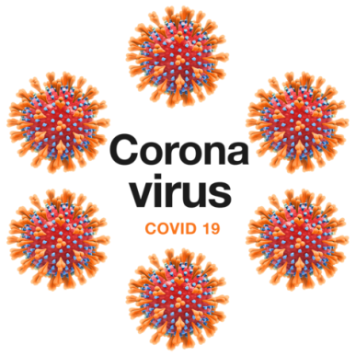 | We want to look at the impact of Covid-19 on adults, their families and communities.
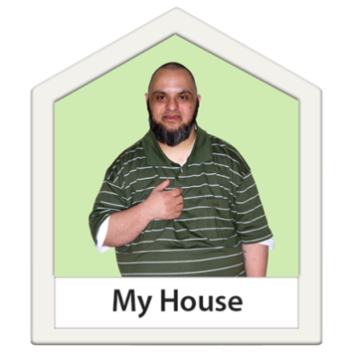 | Also what this tells us about the role our communities should play in supporting people to live independently.
 | We want to hear your story of how the lockdown affected you or how your community supported you.
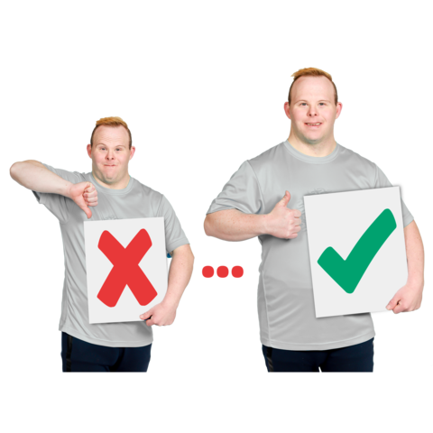 | We would love to hear from you so that we can learn and develop better services for people.
 | You can send your story to nwadass@nwemployers.org.uk.
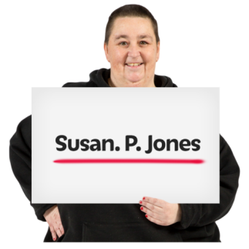 | Please include your name and phone number.
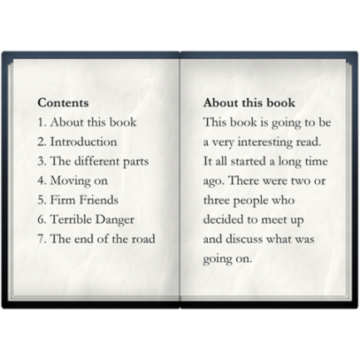 | Your story can be in any format and include whatever you like.  It may help you if you use this form to tell your story.
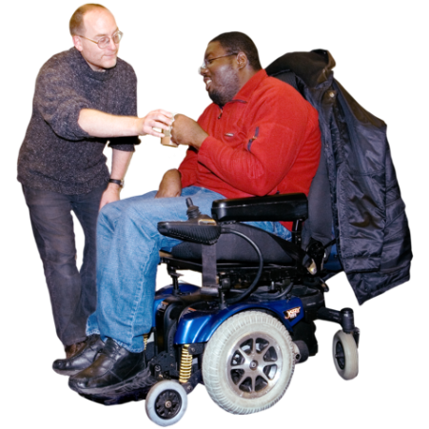 | We want to hear from:  - People who need help to live independently  - People get adult social care  - Family members  - Advocates  - Carers who support a family member  - Care workers in a paid role  - People who volunteered during lockdown to support others  - Community and voluntary organisations  - Informal groups  - Businesses who supported their community with vital services
 | We may invite you to share your story in person at one of our listening sessions in September and October.

